**St Matthew’s Catholic Primary School**

**Phonics Policy**



**Lead: Mrs J Evans**

**Reviewed September 2024**

**To be reviewed: September 2025**

**St. Matthew’s Policy for Phonics 2024-25**

The Aims of English as outlined in the National Curriculum English Programmes of Study. The overarching aim for English in the national curriculum is to promote high standards of language and literacy by equipping pupils with a strong command of the spoken and written word, and to develop their love of literature through widespread reading for enjoyment.

The national curriculum for English aims to ensure that all pupils:

• read easily, fluently and with good understanding.

• develop the habit of reading widely and often, for both pleasure and information.

• acquire a wide vocabulary, an understanding of grammar and knowledge of linguistic conventions for reading, writing and spoken language.

• appreciate our rich and varied literary heritage.

• write clearly, accurately and coherently, adapting their language and style in and for a range of contexts, purposes and audiences.

• use discussion in order to learn; they should be able to elaborate and explain clearly their understanding and ideas.

• are competent in the arts of speaking and listening, making formal presentations, demonstrating to others and participating in debate.

Willingness to participate in a variety of social settings, cooperating well with others and

being able to resolve conflicts effectively. Pupils are encouraged to read their work

aloud in class and to present their work in a variety of ways – presentations and project

work.

Pupils’ cultural development is shown by their:

• Understanding and appreciation of the wide range of cultural influences that have shaped

their own heritage. Cross-curricular links are made during History, R.E. and P.S.H.E.

• Willingness to participate in, and respond to, for example, artistic, musical, sporting,

mathematical, technological, scientific and cultural opportunities. This point links

particularly well with Philosophy, as pupils are given this range as a starting point for

discussion and enquiry. Pupils are then better equipped to start writing, as they have learnt

so much through discussion.

• Interest in exploring, understanding of, and respect for cultural diversity and the extent to

which they understand, accept, respect and celebrate diversity, as shown by their attitudes

towards different religious, ethnic and socio-economic groups in the local, national and

global communities.

**Overview**

The study of phonics develops children’s abilities to segment, blend, read and write for a wide range of purposes. It helps children hear, identify and use different sounds that distinguish one word from another in the English language. Children learn the relationship between the sounds of the spoken language, and the letters or groups of letters or syllables of the written language. The study of phonics enables children to express themselves creatively and imaginatively, as they become enthusiastic and critical readers of stories, poetry and drama - as well as non-fiction and media texts. Children gain an understanding of how language works by looking at its patterns, structures and origins. Children can then apply their knowledge and understanding in a wide range of contexts.

**Aims**

• To provide a consistent approach to teaching phonics in EYFS, KS1 and KS2 (where

applicable) using the Read, Write Inc (RWI) Programme.

• To provide a safe, secure environment where all pupils can flourish, thrive and fulfil their

potential.

• To ensure that all staff are aware of the structure of RWI and receive CPD when needed.

• To promote self-discipline and learning behaviours in-line with the RWI programme.

• To provide information regarding RWI to staff and parents.

• To monitor teaching and learning of RWI, Progress and Assessments.

Children in St. Matthew’s are grouped in homogenous groups according to their reading progress, this is assessed with half termly assessments that are carried out by the RWI/Reading Lead. Once the children are grouped, they will be taught a daily 60-minute RWI session to help them to develop into fluent readers. Reception children will initially have a 20-minute lesson in the Autumn term and build up to a 60-minute lesson during the Summer Term. The daily RWI sessions will be delivered by trained teachers and teaching assistants who work closely with the RWI lead. Throughout the programme the children will be taught the following 3 sets of sounds;

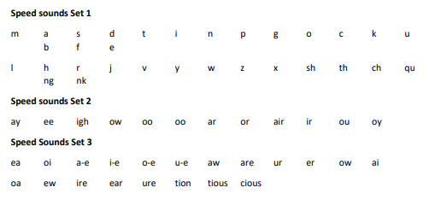

**Organisation**

Pupils in EYFS are in homogenous groups within in Reception and are taught by the EYFS team. Key Stage 1 pupils are streamed across the year groups to ensure children are taught the relevant sounds. In the Summer Term, Reception will be streamed with Key Stage 1 to prepare the children for transition. Pupils in Key stage 2 who are still in need of phonics instruction will receive appropriate group or intervention-based teaching.

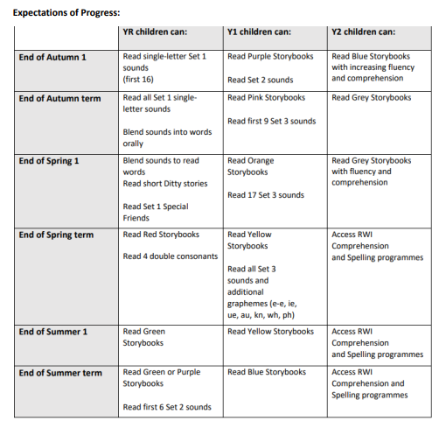

Children may not need to read every book in the programme. The rigorous assessments that are carried out each half term ensures that children are reading the correct books that match the sounds they know. Once the children have completed the RWI programme they have all the skills that they need to read accurately and will progress to reading a wider range of books. At St. Matthew’s we understand that not all children might be working at their age related expectations for reading, which is why we identify which children need extra support and put tutoring in place (see tutoring below).

Tutoring

At St. Matthew’s we understand that some of our pupils need more support in retaining sounds which is why identified children receive daily pinny time and/or 1:1 tutoring in addition to their daily RWI sessions. We believe that early identification and support is paramount which is why regular assessments are vital in identifying the needs and progress of our children. Tutoring is carried out by a trained member of staff and will be in the form of 1:1 tutoring or small group tutoring. The session focuses on the gaps that the children have in their sound recognition. It also focuses on reviewing and reading sounds speedily as well as blending and reading words. The children will receive a 10 minute tutoring session in addition to their RWI session. Pinny time is carried out by the child’s teacher or teaching assistant within the classroom. Children will practise reading the sounds that they have already been taught speedily which will help with their recognition and fluency. They will also practise blending sounds into words using Fred Talk.

**Phonics Screening Check**

In May, Year 1 and some Year 2 children will sit the phonics screening check. The phonics screening check consists of 40 words (real and nonsense) containing the sounds that the children have been taught. During the check the children will be asked to read the words to a teacher. Year 1 staff will be supported to complete the screening check and will receive training on how to administer the check. Results will be analysed and used to inform future planning and practise.

**Assessment of Phonics**

Assessment of phonics will include:

• Children are assessed every half term by the RWI Lead using the programmes termly

assessments which involves reading sounds, real and nonsense words and timed passages to check for fluency.

• Staff use daily assessment for learning in lessons to inform planning, ensuring that lessons

are tailored to the needs of the group.

• Half termly class trackers and group trackers are used to identify children’s progression

through the programme and to identify any children who need extra tutoring.

• Phonics Screening Check completed in Year 1.

• Children who do not pass the check will take the check again in Year 2

**Home Learning**

Parental involvement is key in the acquisition of phonics. Each child in EYFS and Key Stage 1 is provided with a RWI story book to read at home. All story books are fully decodable and match the pupil’s phonic ability. Children who are not yet ready to access story books are given sounds and words to practise at home and are also give a reading for pleasure book for them to enjoy sharing with their family Links are also sent home to parents which provides access to appropriate videos that the children can participate with at home. The videos are specific to the sounds that the children are learning in school and match pupils phonic ability.

**Parental Involvement**

We aim to ensure that our parents are aware of the importance of phonics in their children’s development and understand how their child is learning to read in school and how they can best support them at home. We hold parent meetings to provide them with the confidence and tools to reinforce their child’s learning at home. These meetings also allow time for parents to ask teachers any questions they may have abut phonics and their child’s learning.